

**Start at** [***www.muskegoncc.edu***](http://www.muskegoncc.edu) **and click on** [***Search***](https://mymcc.muskegoncc.edu/) ***for Classes***

**Searching for Classes using WebAdvisor**

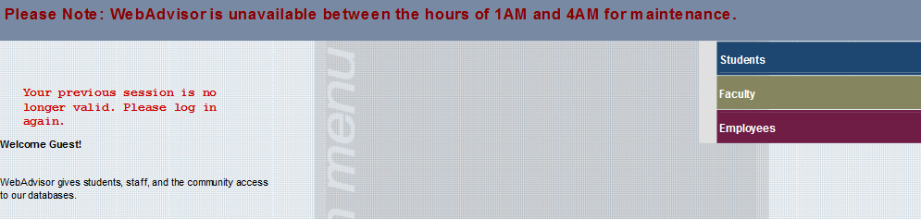

Click on ***Student***

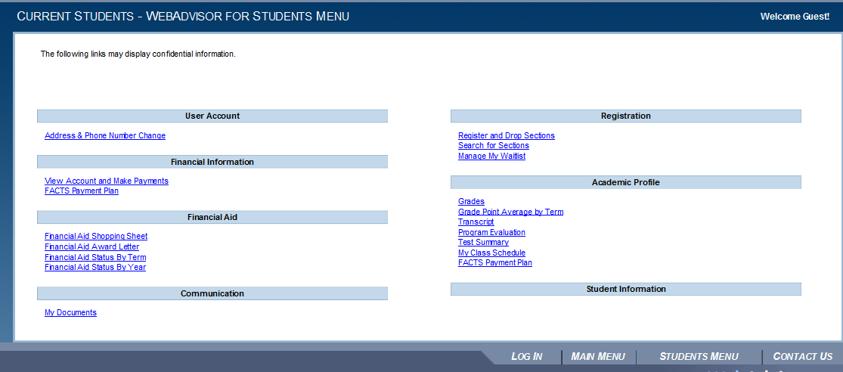

Click on ***Search for Sections***

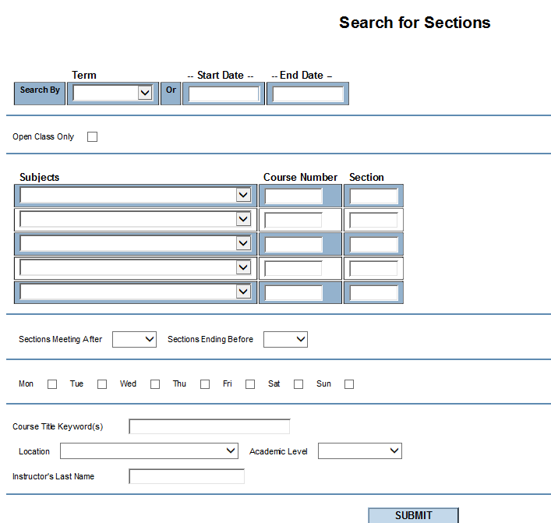

Select the **term** that you would like to see that classes that will be offered and **at least one search criteria** then click **submit**

* You may also search by a start and end date instead of the term if you would like to search for late start classes

**You can search for classes by *Subject* or *Location***

If you add a Course Number, it must contain all letters and numbers of the class. Example: MATH-036A

* Subject is Mathematics & the Course # is 036A