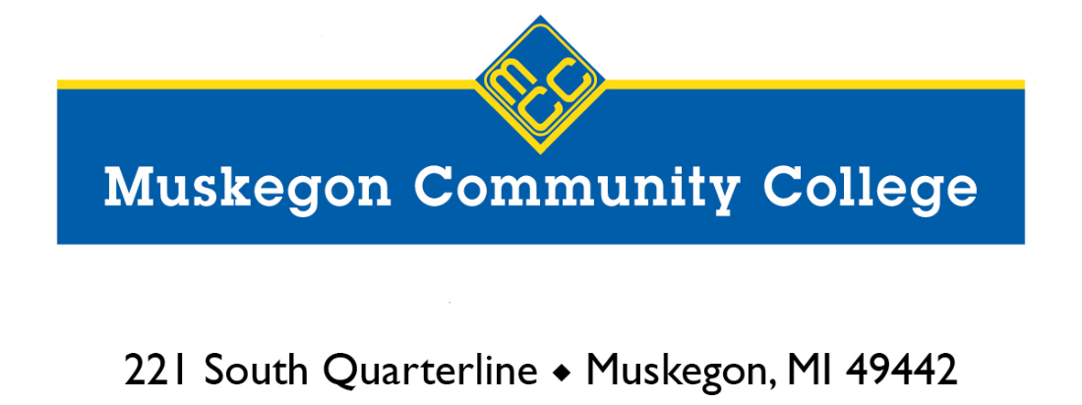

Associate Degree in Nursing to Bachelor of Science in Nursing
Completion Initiative
November 4, 2022

REQUEST FOR PROPOSAL: Associate Degree in Nursing (ADN) to Bachelor of Science in Nursing (BSN) Partnership Agreement

Overview
Muskegon Community College (MCC) invites you to submit a response to the Request for Proposal (RFP) for an ADN to BSN Partnership Agreement.
To be considered, proposals must be received prior to 5:00 p.m. EST on Friday, December 16, 2022. No exceptions will be made to this deadline. Proposals received after that deadline will not be considered.
Proposers shall submit one (1) signed original of this form, along with proposal and attachments as appropriate. Proposals not completed in the manner specified in the RFP will not be evaluated. Proposals may be directed via mail or email to:
Muskegon Community College
ATTN: Dr. Kelley Conrad
221 S. Quarterline
Muskegon, MI 49442
Kelley.conrad@muskegoncc.edu

No bid bond or performance bond is required for this RFP.

Contact Information and Inquiries:
Dr. Kelley Conrad
Provost and Chief Student Services Officer
Kelley.conrad@muskegoncc.edu
Phone: 231-777-0231

REQUEST FOR PROPOSAL
Associate Degree in Nursing (ADN) to
Bachelor of Science in Nursing (BSN) Partnership Agreement

COLLEGE/UNIVERSITY:
CONTACT NAME:
TITLE:
EMAIL:
PHONE:
ADDRESS:
SIGNATURE:
Background
The Michigan FY23 budget includes $56M (federal funds) for the Michigan ADN BSN Completion Grant program. The program will be administered by the Michigan Department of Labor and Economic Opportunity (LEO). The program allows students who have attained an Associate Degree in Nursing (ADN) to complete a Bachelor of Science in Nursing (BSN) on a community college campus in partnership with a public university or not-for-profit independent college. Each community college will be eligible for a minimum of $2M for this project. The funding may be utilized to support any costs related to the program and is designed to be flexible. All funds should be expended by September 30, 2026.

To be eligible, a community college must have:
A signed agreement with a four-year institution, that aligns with the framework developed by the state workgroup
Strategic input and engagement from local health care employers and local workforce development agency

The BSN degree granting institution will design, deliver, and maintain the ADN to BSN completion program including admissions, curriculum design, and accreditation with strategic input from employers and community colleges.

Muskegon Community College is looking to partner with a college/university that offers a dynamic BSN completion track that can meet the needs of working nurses. College/university refers to any accredited Michigan college or university, and from this point forward “university” will refer to both colleges and universities.

Timeline
Muskegon Community College plans to launch an ADN to BSN Partnership Program in Fall 2023. To that end, we have set forth the following schedule for proposals:
Event | Date
Request for Proposal Issued | November 4, 2022
Proposals Due | December 16, 2022
Proposal Review Complete – Submitters Notified | January 6, 2023

Submitters will be notified via email of MCC’s decision to include or exclude them from further involvement in the process. MCC may engage in final negotiations with more than one school.
Muskegon Community College’s Goals
Muskegon Community College awards the ADN to approximately 65 students each year. Most continue to live and work in Muskegon and the surrounding area. The goals of this program partnership are to:
- Provide an affordable and financially competitive pathway from the ADN to the BSN for MCC graduates.
- Provide a local, sustainable option for the BSN completion, with a trusted university partner.
- Provide a seamless transfer experience for students. This includes recognition of, and support for students who work full-time, have children, are first-generation students, and/or have other circumstances that make completion of the BSN more challenging.
- Partner with a university that will award credit for the entire associate degree in nursing, the Michigan Transfer Agreement, and any other Credit for Prior Learning that can accelerate the pathway to a BSN.
Specifications
Muskegon Community College is seeking universities to submit a proposal that meets the specifications below. Please identify any budget needs beyond student tuition and fees.
The proposal needs to address the following program elements:
- Curriculum
- Review of the MCC ADN requirements against the BSN completion program
- Credits granted for number of years worked in the field, if applicable
- Residency requirements
- Breakdown of the ADN to BSN program related to theory/lab/clinical components
- Any university specific graduation requirements
- Requirements related to the MTA (Michigan Transfer Agreement) or acceptance of the MTA
- Capstone requirements
- Brief description of how the university’s program prepares graduates for the diversity of healthcare positions to maximize employment opportunities for our ADN/BSN graduates.
- Brief description of how the university’s program prepares graduates to meet the needs of local healthcare providers, including community health entities.

- Enrollment Management and Services to Students
- University commitment to recruitment activities specific to this program
- Process of admission to the university
- Nursing specific admission requirements, including any limitations
- Application fee to the university
- Tuition and fees
- Willingness to enter into a consortium agreement for financial aid
- Approximate cost of books and supplies
- Scholarship, grant, or discounted tuition opportunities for the student
- Completion rate of university’s current BSN program
- Student support, including academic advising, career services, financial aid support, mental health counseling, and other student basic needs services to ensure students are likely to complete. These could be in conjunction with MCC.
- Learning management system used for hybrid or remote offerings
- Equipment provided to students that attend your university or requirements for specific equipment

- Partnership Design
- Breakdown of program conducted face-to-face on MCC campus vs. hybrid vs. online. Note - the program funding requires a portion of the BSN completion courses be taught in person, on MCC’s campus.
- National accreditation status and documentation
- Course occupancy minimums and maximums
- Opportunities for qualified faculty or staff of MCC to teach for your university
- Timeline for when the first cohort could start
- Requested funding from the state grant and purpose of funding
- University department and mechanism to work with MCC to co-brand and promote the ADN to BSN program
- Length of initial commitment
- Willingness to work with MCC, local employers, and local Michigan Works! Agencies to optimize program recruitment, enrollment, retention, and completion
Proposals must be submitted as downloadable PDF documents.

